**Practical No 1**

**Aim: Configure Routers.**

**Topology Diagram:**

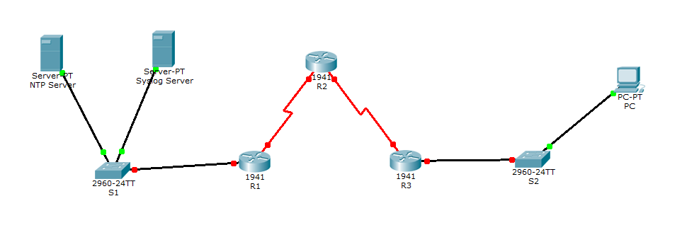

**Assign IP Addresses:**

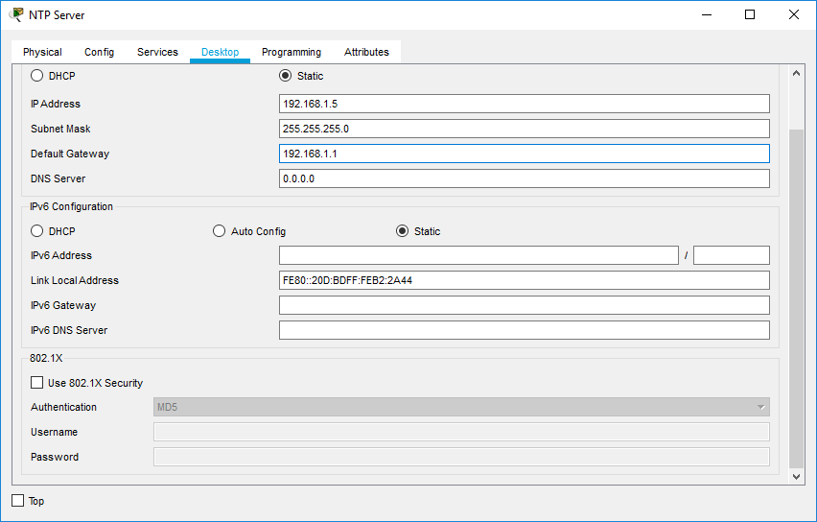

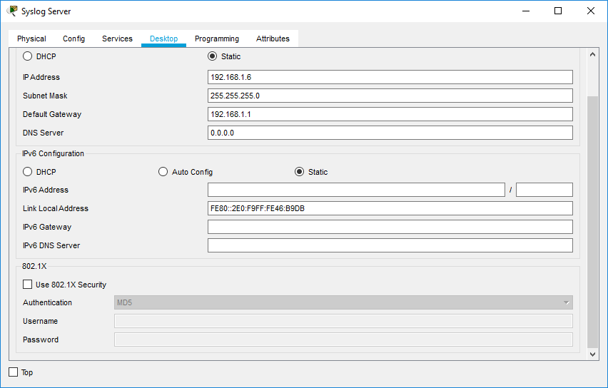

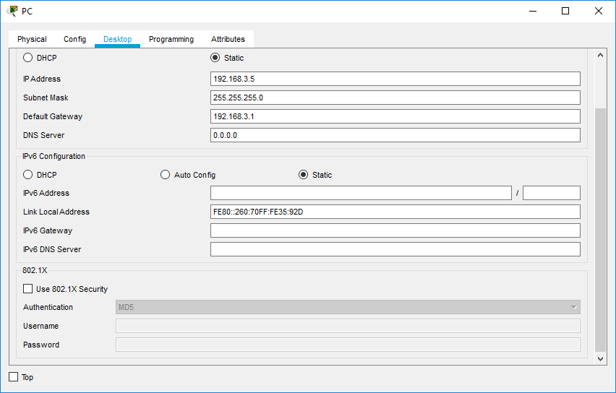

Router>en

Router#conf t

Router(config)#host R1

R1(config)#interface GigabitEthernet0/0

R1(config-if)#ip address 192.168.1.1 255.255.255.0

R1(config-if)#no shut

R1(config)#interface Serial0/0/0

R1(config-if)#en

R1(config-if)#no shut

R1(config-if)#^Z

R1#exit

Router>en

Router#conf t

Router(config)#host R2

R2(config)#interface Serial0/0/0

R2(config-if)#ip address 10.1.1.2 255.255.255.252

R2(config-if)#no shut

R2(config)#interface Serial0/0/1

R2(config-if)#ip address 10.2.2.2 255.255.255.252

R2(config-if)#no shut

R2(config-if)#^Z

R2#exit

Router>en

Router#conf t

Router(config)#host R3

R3 (config)#interface Serial0/0/0

R3 (config-if)#ip address 10.2.2.1 255.255.255.252

R3 (config-if)#no shut

R3 (config)#interface GigabitEthernet0/0

R3 (config-if)#ip address 192.168.3.1 255.255.255.0

R3(config-if)#^Z

R3#exit

**Displaying IP Address Details of Routers:-**

R1>show ip interface brief

Interface IP-Address OK? Method Status Protocol

GigabitEthernet0/0 192.168.1.1 YES manual up up

GigabitEthernet0/1 unassigned YES unset administratively down down

Serial0/0/0 10.1.1.1 YES manual up up

Serial0/0/1 unassigned YES unset administratively down down

Vlan1 unassigned YES unset administratively down down

R2>show ip interface brief

Interface IP-Address OK? Method Status Protocol

GigabitEthernet0/0 unassigned YES unset administratively down down

GigabitEthernet0/1 unassigned YES unset administratively down down

Serial0/0/0 10.1.1.2 YES manual up up

Serial0/0/1 10.2.2.2 YES manual up up

Vlan1 unassigned YES unset administratively down down

R3>show ip interface brief

Interface IP-Address OK? Method Status Protocol

GigabitEthernet0/0 192.168.3.1 YES manual up up

GigabitEthernet0/1 unassigned YES unset administratively down down

Serial0/0/0 10.2.2.1 YES manual up up

Serial0/0/1 unassigned YES unset administratively down down

Vlan1 unassigned YES unset administratively down down

**Configure OSPF on routers:-**

R1>en

R1#conf t

R1(config)#router ospf 1

R1(config-router)#network 192.168.1.0 0.0.0.255 area 0

R1(config-router)#network 10.1.1.0 0.0.0.3 area 0

R1(config-router)#^Z

R1#exit

R2>en

R2#conf t

R2(config)#router ospf 1

R2(config-router)#network 10.1.1.0 0.0.0.3 area 0

R2(config-router)#network 10.2.2.0 0.0.0.3 area 0

R2(config-router)#^Z

R2#exit

R3>en

R3#conf t

R3(config)#router ospf 1

R3(config-router)#network 192.168.3.0 0.0.0.255 area 0

R3(config-router)#network 10.2.2.0 0.0.0.3 area 0

R3(config-router)#^Z

R3#exit

**Displaying routing table of routers:-**

R1>show ip route

10.0.0.0/8 is variably subnetted, 3 subnets, 2 masks

C 10.1.1.0/30 is directly connected, Serial0/0/0

L 10.1.1.1/32 is directly connected, Serial0/0/0

O 10.2.2.0/30 [110/128] via 10.1.1.2, 00:16:28, Serial0/0/0

192.168.1.0/24 is variably subnetted, 2 subnets, 2 masks

C 192.168.1.0/24 is directly connected, GigabitEthernet0/0

L 192.168.1.1/32 is directly connected, GigabitEthernet0/0

O 192.168.3.0/24 [110/129] via 10.1.1.2, 00:01:37, Serial0/0/0

R2>show ip route

10.0.0.0/8 is variably subnetted, 4 subnets, 2 masks

C 10.1.1.0/30 is directly connected, Serial0/0/0

L 10.1.1.2/32 is directly connected, Serial0/0/0

C 10.2.2.0/30 is directly connected, Serial0/0/1

L 10.2.2.2/32 is directly connected, Serial0/0/1

O 192.168.1.0/24 [110/65] via 10.1.1.1, 00:17:07, Serial0/0/0

O 192.168.3.0/24 [110/65] via 10.2.2.1, 00:02:15, Serial0/0/1

R3>show ip route

10.0.0.0/8 is variably subnetted, 3 subnets, 2 masks

O 10.1.1.0/30 [110/128] via 10.2.2.2, 00:08:22, Serial0/0/0

C 10.2.2.0/30 is directly connected, Serial0/0/0

L 10.2.2.1/32 is directly connected, Serial0/0/0

O 192.168.1.0/24 [110/129] via 10.2.2.2, 00:08:22, Serial0/0/0

192.168.3.0/24 is variably subnetted, 2 subnets, 2 masks

C 192.168.3.0/24 is directly connected, GigabitEthernet0/0

L 192.168.3.1/32 is directly connected, GigabitEthernet0/0

**(1)OSPF MD5 authentication**

**Configure OSPF MD5 authentication on Routers:-**

R1>en

R1#conf t

R1(config)#router ospf 1

R1(config-router)#area 0 authentication message-digest

R1(config-router)#^Z

R1#exit

R2>en

R2#conf t

R2(config)#router ospf 1

R2(config-router)#area 0 authentication message-digest

R2(config-router)#^Z

R2#exit

R3>en

R3#conf t

R3(config)#router ospf 1

R3(config-router)#area 0 authentication message-digest

R3(config-router)#^Z

R3#exit

**Configure the MD5 key for all the routers:-**

R1>en

R1#conf t

R1(config)#interface Serial0/0/0

R1(config-if)#ipospf message-digest-key 1 md5 mdpwd

R1(config-if)#^Z

R1#exit

R2>en

R2#conf t

R2(config)#interface Serial0/0/0

R2(config-if)#ipospf message-digest-key 1 md5 mdpwd

R2(config)#interface Serial0/0/1

R2(config-if)#ipospf message-digest-key 1 md5 MD5pa55

R2(config-if)#^Z

R2#exit

R3>en

R3#conf t

R3(config)#interface Serial0/0/0

R3(config-if)#ipospf message-digest-key 1 md5 MD5pa55

R3(config-if)#^Z

R3#exit

**Displaying OSPF Details of the Routers:-**

R1>show ipospf interface Serial0/0/0

Serial0/0/0 is up, line protocol is up

Internet address is 10.1.1.1/30, Area 0

Process ID 1, Router ID 192.168.1.1, Network Type POINT-TO-POINT, Cost: 64

Transmit Delay is 1 sec, State POINT-TO-POINT, Priority 0

No designated router on this network

No backup designated router on this network

Timer intervals configured, Hello 10, Dead 40, Wait 40, Retransmit 5

Hello due in 00:00:05

Index 2/2, flood queue length 0

Next 0x0(0)/0x0(0)

Last flood scan length is 1, maximum is 1

Last flood scan time is 0 msec, maximum is 0 msec

Neighbor Count is 1 , Adjacent neighbor count is 1

Adjacent with neighbor 10.2.2.2

Suppress hello for 0 neighbor(s)

**Message digest authentication enabled**

**Youngest key id is 1**

R2>show ipospf interface Serial0/0/0

Serial0/0/0 is up, line protocol is up

Internet address is 10.1.1.2/30, Area 0

Process ID 1, Router ID 10.2.2.2, Network Type POINT-TO-POINT, Cost: 64

Transmit Delay is 1 sec, State POINT-TO-POINT, Priority 0

No designated router on this network

No backup designated router on this network

Timer intervals configured, Hello 10, Dead 40, Wait 40, Retransmit 5

Hello due in 00:00:00

Index 1/1, flood queue length 0

Next 0x0(0)/0x0(0)

Last flood scan length is 1, maximum is 1

Last flood scan time is 0 msec, maximum is 0 msec

Neighbor Count is 1 , Adjacent neighbor count is 1

Adjacent with neighbor 192.168.1.1

Suppress hello for 0 neighbor(s)

**Message digest authentication enabled**

**Youngest key id is 1**

R3>show ipospf interface Serial0/0/0

Serial0/0/0 is up, line protocol is up

Internet address is 10.2.2.1/30, Area 0

Process ID 1, Router ID 10.2.2.1, Network Type POINT-TO-POINT, Cost: 64

Transmit Delay is 1 sec, State POINT-TO-POINT, Priority 0

No designated router on this network

No backup designated router on this network

Timer intervals configured, Hello 10, Dead 40, Wait 40, Retransmit 5

Hello due in 00:00:00

Index 1/1, flood queue length 0

Next 0x0(0)/0x0(0)

Last flood scan length is 1, maximum is 1

Last flood scan time is 0 msec, maximum is 0 msec

Neighbor Count is 1 , Adjacent neighbor count is 1

Adjacent with neighbor 10.2.2.2

Suppress hello for 0 neighbor(s)

**Message digest authentication enabled**

**Youngest key id is 1**

1. **NTP**

**Check Clock Time in the routers:-**

R1>show clock

*0:22:34.253 UTC Mon Mar 1 1993

R2>show clock

*0:22:34.253 UTC Mon Mar 1 1993

R3>show clock

*0:22:34.253 UTC Mon Mar 1 1993

**Configure NTP Server:-**

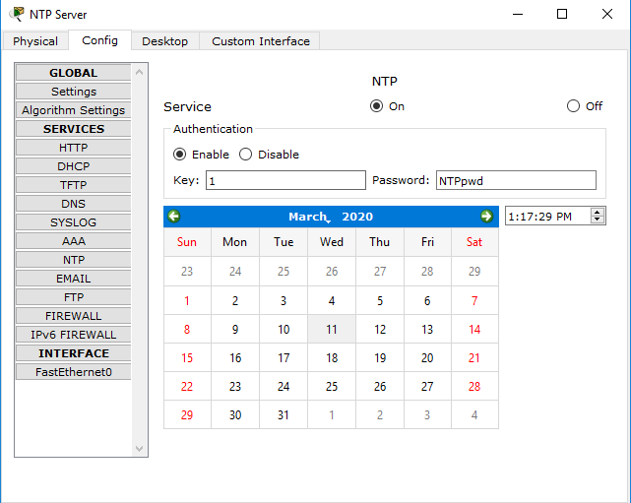

**Configure NTP Client:-**

R1>en

R1#conf t

R1(config)#ntp server 192.168.1.5

R1(config)#ntp update-calendar

R1(config)#^Z

R1#exit

R2>en

R2#conf t

R2(config)#ntp server 192.168.1.5

R2(config)#ntp update-calendar

R2(config)#^Z

R2#exit

R3>en

R3#conf t

R3(config)#ntp server 192.168.1.5

R3(config)#ntp update-calendar

R3(config)#^Z

R3#exit

**Configure NTP authentication and to timestamp log messages on the routers:-**

R1>en

R1#conf t

R1(config)#ntp authenticate

R1(config)#ntp trusted-key 1

R1(config)#ntp authentication-key 1 md5 NTPpwd

R1(config)#service timestamps log datetimemsec

R1(config)#^Z

R1#exit

R2>en

R2#conf t

R2(config)#ntp authenticate

R2(config)#ntp trusted-key 1

R2(config)#ntp authentication-key 1 md5 NTPpwd

R2(config)#service timestamps log datetimemsec

R2(config)#^Z

R2#exit

R3>en

R3#conf t

R3(config)#ntp authenticate

R3(config)#ntp trusted-key 1

R3(config)#ntp authentication-key 1 md5 NTPpwd

R3(config)#service timestamps log datetimemsec

R3(config)#^Z

R3#exit

**Check updated UTC Clock Time in the routers:-**

R1>show clock

12:20:53.244 UTC Sat Jan 5 2019

R2>show clock

12:20:53.244 UTC Sat Jan 5 2019

R3>show clock

12:20:53.244 UTC Sat Jan 5 2019

1. **Syslog**

**Configure Routers to Log Messages to the Syslog Server :-**

R1>en

R1#conf t

R1(config)#logging host 192.168.1.6

R1(config)#^Z

R1(config)#exit

R2>en

R2#conf t

R2(config)#logging host 192.168.1.6

R2(config)#^Z

R2(config)#exit

R3>en

R3#conf t

R3(config)#logging host 192.168.1.6

R3(config)#^Z

R3(config)#exit

**Verify logging configuration on Routers:-**

R1#show logging

**Syslog logging: enabled** (0 messages dropped, 0 messages rate-limited,

0 flushes, 0 overruns, xml disabled, filtering disabled)

No Active Message Discriminator.

No Inactive Message Discriminator.

Console logging: level debugging, 6 messages logged, xml disabled,

filtering disabled

Monitor logging: level debugging, 6 messages logged, xml disabled,

filtering disabled

Buffer logging: disabled, xml disabled,

filtering disabled

Logging Exception size (4096 bytes)

Count and timestamp logging messages: disabled

Persistent logging: disabled

No active filter modules.

ESM: 0 messages dropped

Trap logging: level informational, 6 message lines logged

Logging to 192.168.1.6 (udp port 514, audit disabled,

authentication disabled, encryption disabled, link up),

2 message lines logged,

0 message lines rate-limited,

0 message lines dropped-by-MD,

xml disabled, sequence number disabled

filtering disabled

R2#show logging

**Syslog logging: enabled** (0 messages dropped, 0 messages rate-limited,

0 flushes, 0 overruns, xml disabled, filtering disabled)

No Active Message Discriminator.

No Inactive Message Discriminator.

Console logging: level debugging, 6 messages logged, xml disabled,

filtering disabled

Monitor logging: level debugging, 6 messages logged, xml disabled,

filtering disabled

Buffer logging: disabled, xml disabled,

filtering disabled

Logging Exception size (4096 bytes)

Count and timestamp logging messages: disabled

Persistent logging: disabled

No active filter modules.

ESM: 0 messages dropped

Trap logging: level informational, 6 message lines logged

Logging to 192.168.1.6 (udp port 514, audit disabled,

authentication disabled, encryption disabled, link up),

2 message lines logged,

0 message lines rate-limited,

0 message lines dropped-by-MD,

xml disabled, sequence number disabled

filtering disabled

R3#show logging

**Syslog logging: enabled** (0 messages dropped, 0 messages rate-limited,

0 flushes, 0 overruns, xml disabled, filtering disabled)

No Active Message Discriminator.

No Inactive Message Discriminator.

Console logging: level debugging, 6 messages logged, xml disabled,

filtering disabled

Monitor logging: level debugging, 6 messages logged, xml disabled,

filtering disabled

Buffer logging: disabled, xml disabled,

filtering disabled

Logging Exception size (4096 bytes)

Count and timestamp logging messages: disabled

Persistent logging: disabled

No active filter modules.

ESM: 0 messages dropped

Trap logging: level informational, 6 message lines logged

Logging to 192.168.1.6 (udp port 514, audit disabled,

authentication disabled, encryption disabled, link up),

2 message lines logged,

0 message lines rate-limited,

0 message lines dropped-by-MD,

xml disabled, sequence number disabled

filtering disabled

**Examine logs of the Syslog Server:-**

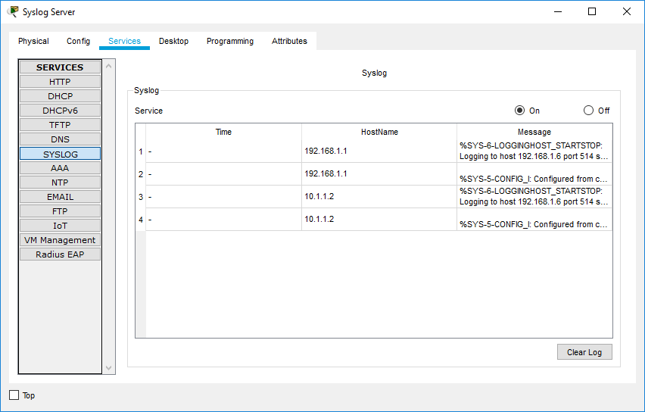

1. **SSH**

**Configure SSH on R3 :-**

R3>en

R3#conf t

R3(config)#ip domain-name securityincomputing.com

R3(config)#username SSHadmin privilege 15 secret sshpwd

R3(config)#line vty 0 4

R3(config-line)#login local

R3(config-line)#transport input ssh

R3(config-line)#crypto key zeroizersa

R3(config)#crypto key generate rsa

The name for the keys will be: R3.securityincomputing.com

Choose the size of the key modulus in the range of 360 to 2048 for your

General Purpose Keys. Choosing a key modulus greater than 512 may take

a few minutes.

How many bits in the modulus [512]: 1024

% Generating 1024 bit RSA keys, keys will be non-exportable...[OK]

R3(config)#ipssh time-out 90

*Mar 1 1:51:24.621: %SSH-5-ENABLED: SSH 1.99 has been enabled

R3(config)#ipssh authentication-retries 2

R3(config)#ipssh version 2

R3(config)#^Z

R3#exit

**Connect to R3 using telnet and SSH on PC:-**

